**Department of Computer Engineering**

COM425 - Engineering Project-1

**Face Mask Detection with Java**

**Advisor:**

TABLE OF CONTENTS

Acknowledgment…………………………………………………………………………………………………..3

Abstract. 4

CHAPTER ONE – INTRODUCTION 1

1.1. Statement Of The Problem 1

1.2. Purpose Of The Study 1

1.3. Significance Of The Study 2

1.4. Aims & Objectives Of The Study 2

1.5. Scope Of The Study 3

1.6. Constraints & Limitations 4

1.7. Definition Of Terms 5

CHAPTER TWO - PAST STUDIES 8

2.1. Literature Review 8

CHAPTER THREE – SYSTEM ANALYSIS & DESIGN 12

3.1. Introduction 12

3.2. System Analysis 12

3.2.1 Detailed Definition Of The Problem 14

3.2.2. Feasibility Study 15

3.3. Methods Of Data Collection 15

3.4. Problems Of Existing System Or Drawbacks Identified In The Present System 16

3.5. Data Preparation 16

3.6. User Preparation 17

3.7. Objective Of The New Design 17

3.8. Program Structure 18

3.9. File Maintenance Module 18

3.10. Main Menu Specification 19

3.10.1. Output Specifications 19

3.10.2. Input Specifications 19

3.11. Overview Of The Proposed System Diagram 23

CHAPTER FOUR – SUMMARY, RECOMMENDATION & CONCLUSION 26

4.1. Summary 26

4.2. Recommendation 26

4.3. Conclusion 26

Presentation Link 27

References 27

# Acknowledgment

The success and final working outcome of this project required plenty of hard work, guidance and assistance from professors, online courses and documentations. I take this opportunity to express my sincere thanks and deep gratitude to all the people who extended their time and helped me in completing this project successfully. I’m highly thankful to **Prof. Dr.** my advisor for this course Engineering Project-I for providing me continuous and invaluable guidance throughout the project in spite of her busy schedule. The kind advices that I got from her always inspired me to put my best effort to complete this project in the best possible way. I’m extremely thankful to her for providing such a pleasant support and guidance. I also want to mention the importance of our professors who played a significant role and showed us the right path to learn new things and accept new challenges. I’m thankful to urge enough encouragement, support and guidance from all Teaching staffs of the Department of Computer Engineering Istanbul Aydin University which helped us successfully and made us better individuals and always prepared us for new coming challenges.

# Abstract

Due to the recent corona virus pandemic people around the world were pushed to face new challenges. In this context of uncertainty, we can all play our role by contributing to the fight against this disease. This is an excellent opportunity to put technology at the service of humanity. From my place I could try to contribute with the tools that I can work on. So in here I will develop an android application to detect face masks in smart-phones using android studio as a platform and Java as my language code in this project. The emphasis of this project here is to detect face masks in smart-phones application, Face Mask Detection usually uses Artificial Network to recognize if a user is not wearing a mask, and the app can be connected to any existing or new IP mask detection cameras to detect people without a mask. Application users can also add faces and phone numbers to send them an alert in case they are not wearing a mask.

Chapter One

Introduction

# Chapter One – Introduction

# STATEMENT OF THE PROBLEM

Face Masks are not perfect barriers to transmission, but they don’t need to be perfect if they aren’t used alone. Universal mask use should be accompanied by other public health measures such as physical distancing, testing, contact tracing and restrictions on large gatherings. Those measures aren’t perfect either, but when many imperfect measures are combined at a community level, they can be very effective at slowing transmission and reducing infections. Face Masks can also reduce the inequitable impact of the pandemic, particularly for those who live in crowded environments where physical distancing is difficult, and for those who work in frontline roles where there is a greater risk of exposure to the virus.

Last but not least, wearing a face mask isn’t a restriction of our freedom. Rather, it helps us to regain freedom by reducing virus transmission in a community and making every interaction safer. Freedom for people to go to work, attend school, interact with others, and most importantly freedom from illness and fear.

# PURPOSE OF THE STUDY

The purpose or goal of this study is to create easy to use application software that can detect face masks and to understand how face mask detection works and its importance to the community during this pandemic. As we know COVID-19 has changed our daily life and continues to do so, having such a program can make the world easier as it can be used in stores, public institutes like libraries etc., Having this application used in public places will remind customers to wear face masks and the accompanying obligation to check for customer/visitor compliance. Face mask detection can help to identify individuals who are wearing face masks and those who aren’t, as was mentioned before it can be used in public institutes where there will be sensors which will be trained to visually count all the people and recognize whether a person is wearing a face mask or not as the sensor mimics the human eye and can thus detect a masked face

This project can help the use of the face mask, a solution that is within everyone’s reach and today everyone has a smart-phone, so perhaps with the use of a mobile application that recognizes face masks it could help solve this problem.

# SIGNIFICANCE OF THE STUDY

To talk about the significance of this project, first let’s refer to the problem to understand the importance of such a project to our community, companies and individuals. For community the findings of this study will result to the benefit of the society considering that technologies play an important role in our lives today. The greater demand for people who have business to follow justifies the need for more effective applications. In the presence of such an application people will be guided to wear masks for their safety. For the researcher the study will help them uncover critical areas in the educational process that many researchers were not able to explore. Thus, this will add more advantages about how technologies are useful in critical moments.

# AIMS & OBJECTIVES OF THE STUDY

The aim of this project is to create application software that can be used on a wide region by communities, companies and individuals that will help them to achieve better numbers in terms to slow the spread of the virus. The technological community has also been a part of these endeavors. In particular, developments for monitoring social distancing or identifying face masks have made the headlines. But all this hype and anxiety to show off results as fast as possible, added up to the usual technology factor, may be signaling the wrong idea that solving some of these use cases is almost trivial due to the mighty powers of technology.

In an effort to paint a more complete picture, I decided to show the objective of this application software and the creative process of Face Mask Detector in mobile/computer vision:

* **Detect people** that pass through a security-like camera.
* **Identify face** mask usage.
* **Collect reliable** statistics and estimate the number of people wearing masks.

The aim of this study is that by using this application software (Face Mask Detector) in our daily routine places such as school, work and transportation, it will force us to wear face masks which will affect the spread of the virus and will help us to slowly go back to our normal life.

# SCOPE OF THE STUDY

The approach of this project is to utilize two-stage detectors; first a face detector is applied, to retrieve the faces positions. Then each face is cropped and prepossessed to be feed into the second model which will do a binary classification detecting between "mask" or "no-mask".

Below is a brief explanation for you to fully understand.

**Adding the Face Recognition Step:**

The original code will work here with a single model which will be trained on the dataset and computes the results in one single step. For this app, we need to implement the two steps detection. Most of the work will consist in splitting the detection;

1. Face detection
2. Mask detection

For the face detection step I’m going to use the Google ML kit. It consists of two bitmaps;

1. The rgb-Frame-Bitmap( where the preview frame is copied )
2. The cropped-Bitmap ( which is originally used to feed the inference mode )

I’m going to define two additional bitmaps for processing;

1. The portrait-Bmp (It is simply to rotate the input frame in portrait mode for devices that have the sensor in landscape orientation)
2. The face-Bmp (is used to draw every detected face, cropping its detected location, and re-scaling to 224 x 224 px to be used as input of the MobileNetV2 model )

When the frames arrive the face detector is used. Face detection will be done on the croppedBitmap, since it is smaller it can speed up the detection process.

If faces are detected, the original frame is drawn in the portraitBmp bitmap to proceed with the second step detection. For each detected face, its bounding box is retrieved and mapped from the cropped space to the original space. This way we can get a better resolution image to feed the mask detector. Face cropping will be done by translating the portrait bitmap to the face's origin and scaling in such a way the face bounding box size matches the 224x224 pixels. Finally the mask detector is called.

**Adding the mask detection step:**

First the TensorFlow Lite model file will be added to the assets folder of the project.

And I will adjust the required parameters to fit our model requirements in the Detector Activity configuration section. I will set the input size of the model to **INPUT_SIZE = 224,** and**QUANTIZED = false**. Then we need to point to the mask detector file. Also we can create a label map text file with the classes names "mask" and "no-mask", to have a better resolution of our detector we can define a larger preview size to (800x600) px.

# CONSTRAINTS & LIMITATIONS

**The constraints for this project can be**:

* **Time constrain:** which is the time it will take to build this project until we reached to its final output.
* **Scope constraint**: this project has a wide audience and can be used in many public institutes, since we are passing through this pandemic together this project targets most of the people for example employees in companies, airports, doctors and patients in hospitals, teachers and students in schools, universities and libraries and so on.
* **Cost constrain**: this project’s cost will not be high because it will be mobile/computer application software.

**The limitations of this project will be**:

* **The first limitation**: will be to connect different back-end and front-end programming languages and frameworks to make them work in a suitable way
* **The second limitation**: will be having a database. This project will contain a huge database and dataset to hold all the data for the images, since all the images will be inserted manually in the database it will take time to save the data.

# DEFINITION OF TERMS

**Bitmap**

Bitmaps are defined as a regular rectangular mesh of cells called pixels, each pixel containing a color value. They are characterized by only two parameters, the number of pixels and the information content (color depth) per pixel. There are other attributes that are applied to bitmaps but they are derivations of these two fundamental parameters.

**The cropped-Bitmap**

Cropped-Bitmapimplements the lSupportlnitialize interface to optimize initialization on multiple properties. Property changes can occur only during object initialization.

**The portrait-Bmp**

Portrait-Bmp is simply to rotate the input frame in portrait mode for devices that have the sensor in landscape orientation.

**The face-Bmp**

The face-Bmp is used to draw every detected face, cropping its detected location, and re-scaling to 224 x 224px to be used as input of the MobileNetV2 model.

**Keras**

The Keras module is a high-level deep learning framework that provides an easy-to-use interface for building, training, and deploying neural networks. It is written in Python and was developed with a focus on enabling rapid experimentation and prototyping of deep learning models.

**Database**

Structured set of data held in a computer mostly in tables, especially one that is accessible in various ways.

**Framework**

It’s a platform for developing software applications. It provides a foundation on which software developers can build programs for a specific platform. A framework is built on another programming language and it adds easier to use functions.

**UML**

UML, short for Unified Modeling Language, is a standardized modeling language consisting of an integrated set of diagrams, developed to help system and software developers for specifying, visualizing, constructing and documenting the artifacts of software systems, as well as for business and other non-software systems.

Chapter Two

Past Studies

# CHAPTER Two - PAST STUDIES

# LITERATURE REVIEW

The use of face masks helps to prevent the transmission of bacteria and viruses. In this project review we will describe the history of face masks from the middle age to modern times. The review will be divided in two parts, the first review will talk about the history of face masks, and the second review will concentrate on the benefits of wearing facemasks in modern times.

Until 1910, the utilization of face masks was common in surgery and in the general hospitals, however some of them used to wear a multilayer face mask made of gauze, this multilayer face mask was illustrated by the British Surgeon B.G.A Monyihan as shown in the figure below.

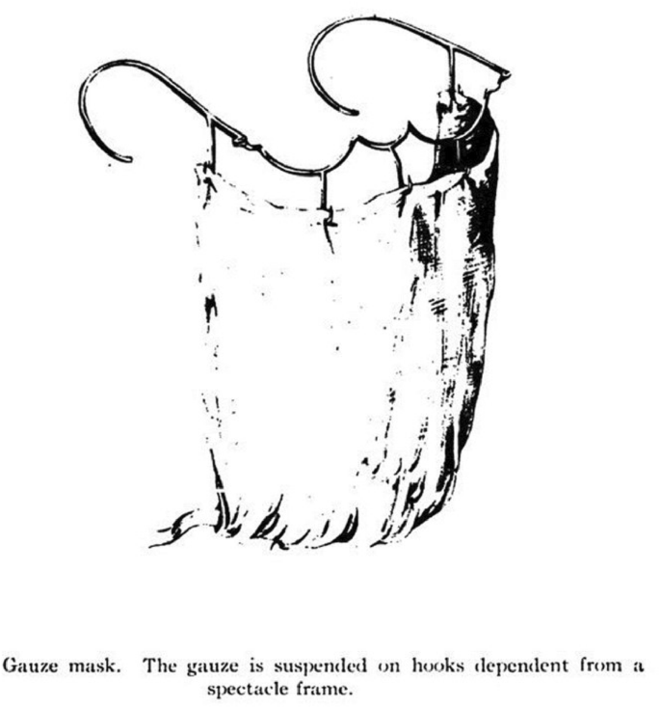

Figure 1. Shows the first Face mask following Berkeley George Andrew Moynihan (1865-1936) was used in an operation ([Fig. 1](https://eurjmedres.biomedcentral.com/articles/10.1186/s40001-020-00423-4/figures/2))

In 1920s the face mask (surgical mask) was first used in small surgery, first in the operating rooms of Germany and USA, the mask was then renounced for a long period of time. There was still no hint for a face mask during those days. In 1927, Martin Kirschner, who held the chair for surgery in Heidelberg, described the necessity of wearing a facemask [1]. In his books he started to mention face masks and how they can reduce the number of germs[2]. In the United States following the First World War, researches were made about face masks [3]. Still, face masks were not generally accepted, which can be seen in the figures below [4] or drawings.While nurses were already wearing face masks made of cloth or gauze, the head physicians rejected them in all surgeries face masks was not allowed.

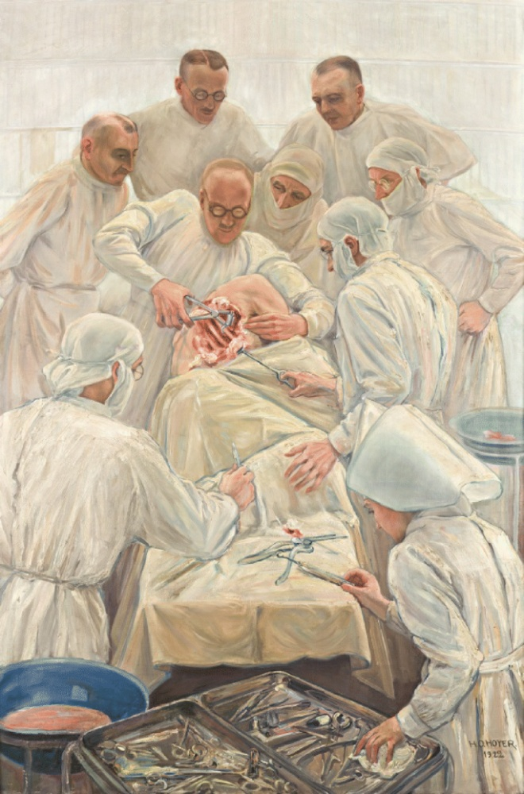

Figure 2.Shows doctors during surgery in Middle Ages were surgery/face masks wasn’t allowed [5].

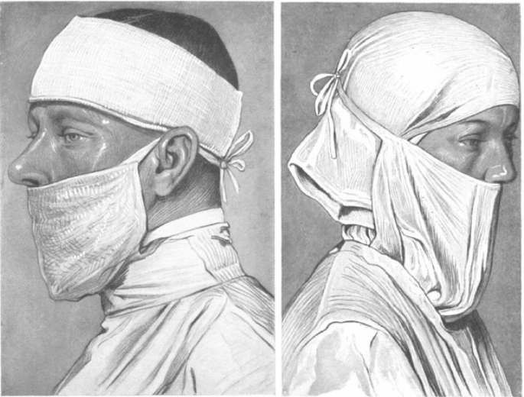

Figure 3.Shows how the face masks was used as it wasn’t common to cover the nose [[6]](https://eurjmedres.biomedcentral.com/articles/10.1186/s40001-020-00423-4/figures/4)

In the middle of the 1930’s, the role of face masks started to gain acceptance in Germany **[6]** and the USA [7]. Beginning in the mid 1960’s the use of face masks made of paper and fleece was introduced all over the world. Still in the 1990’s a study was made to resolve discussion if face masks would reduce wound infections [8]. Today following recommendations from ministry of health, indicates that facemasks helps to stop transmission of the virus and its one of our weapons in this pandemic [9].

During this pandemic, the use of face masks seems to be an accepted procedure wordlwide, which will help this project to take part and play an important role in identifying and helping the community to slowly stop the flow of this virus.

Chapter Three

System Analysis & Design

# CHAPTER Three – SYSTEM ANALYSIS & DESIGN

# 3.1. INTRODUCTION

System Analysis and design intents to help us to understand its importance in developing system applications that meets the user’s requirements, conform to the operational standards of an organization and therefore it achieves the goal of the organization. System analysis and design examines carefully what a system application has to do and how to do them.

# 3.2. SYSTEM ANALYSIS

The face mask detection project aims to develop a system that can detect whether a person is wearing a face mask or not in an image or video stream. The project utilizes the Python programming language along with specific libraries such as pandas, OpenCV, and Keras for data manipulation, image processing, and deep learning model development, respectively.

To begin, a dataset of labeled images is collected, containing examples of individuals both wearing and not wearing face masks. This dataset will serve as the foundation for training the face mask detection model. Preprocessing steps are applied to the dataset using the pandas library, which includes resizing the images, normalizing pixel values, and potentially augmenting the data to enhance model performance.

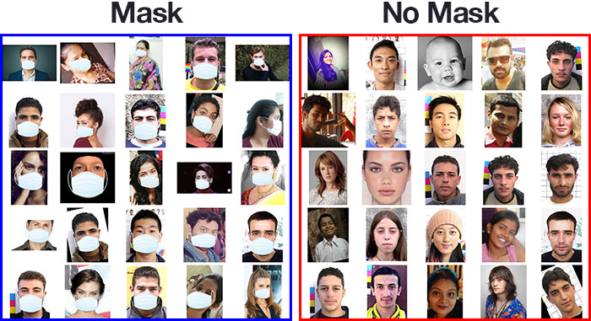

Figure 4.Shows one dataset for people with mask, the other dataset is for people without mask.

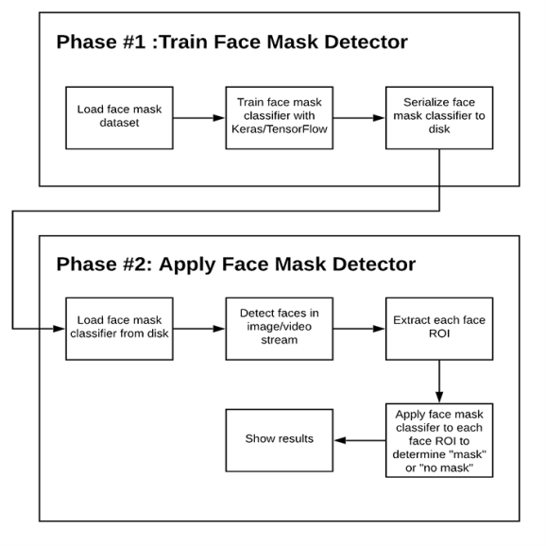Next, a suitable deep learning model architecture is selected for face mask detection. The Keras library is utilized for this purpose. Various pre-existing models such as MobileNet, ResNet, or YOLO could be considered, but we are using a custom model designed in Keras.

Figure 5.The process of the two phases that this project will work on, phase1 which is for the face detection and phase 2 which is for the mask detection

The dataset is divided into training and validation sets to train and evaluate the selected model. The training process involves utilizing appropriate loss functions and optimization algorithms within Keras. Throughout the training process, the model's performance is monitored, and hyperparameters may be adjusted if necessary.

Once the model is trained, it is evaluated on the validation set to assess its performance metrics, including accuracy, precision, and recall. If the model's performance is satisfactory, it can be further tested on a separate test set to evaluate its generalization capability on unseen data.

In summary, the face mask detection system analysis employs the pandas library for data manipulation, OpenCV for image processing, and Keras for deep learning model development. The process involves data collection and preprocessing, model selection and training, evaluation and testing.

Lastly, this project is specified for detecting face mask using webcams or even security cameras if updated good. We will write it with Python programming language. In the Figure below you will see an explanation/algorithm of how this project designs work

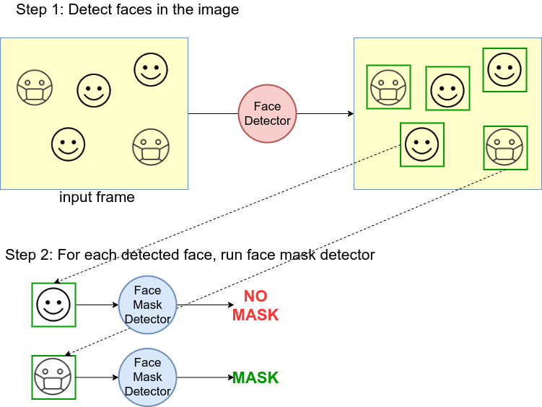

Figure 6.Step1 will detect faces in the dataset and Step 2 will run the face mask detector for each detected face

The above example is modified from the Keras's object detection, to be used with the face mask model described above. In this project we will focus more on making it work on Android or web app but doing it on the other platforms would simply consist of doing the similar procedure.

Once the model was created and tested, we used Streamlit module to create a simple web app. The application has one button which opens up the camera use our model in order to predict if the person sitting infornt of the camera is wearing mask or not. The design of web application is shown in figure 6.1:

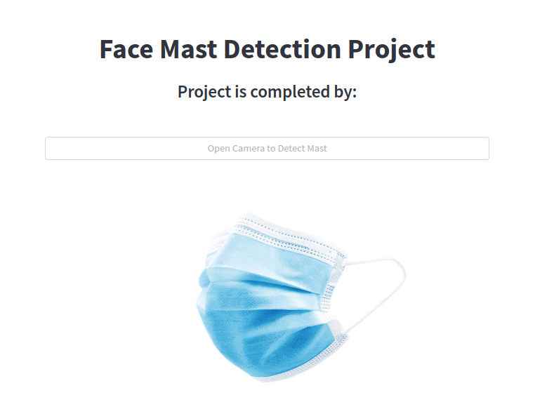

**Figure 6.1**: Web application

# 3.2.1 DETAILED DEFINITION OF THE PROBLEM

The study and analysis of faces captured by cameras address a wide range of challenges, which will have a direct impact on the computer automated face mask detection. The main problems that can limit or stop this project from working and makes it hard for this project application system to detect masked and un-masked faces are:

* **Pose Variations:**

Head movements which is also known as the centric rotation angles, it could lead to substantial changes in face appearance.

* **Image resolution and modality:**

Usual factors influencing Face mask detection are related to the quality and resolution of the face image or to the setup of the digital equipment capturing the face.

* **Availability and quality of face datasets:**

As we know each face mask detections require an available, reliable and realistic face database in order to perform the face search within it.

# 3.2.2. FEASIBILITY STUDY

For this project it can be upgraded with more tools and functions that the user can get help of for example determining the sizes of the photos and images that is wanted, it is important and is related to that project or so and adding a much more complex Tensor-Flow and a larger database to make the fetching faster if it was searched beforehand , with these kind of upgrades to this project or even with its currently form it can be deployed to the internet and with adding codes to make it like a product but not a onetime product yet it can be a subscription based software with first month of trial, some example to such software can be the face recognition apps that it gives free use till some point and after that a subscription must be chosen.

# 3.3. METHODS OF DATA COLLECTION

Data collection is an important part of any project to determine what to show and what to hide let’s start by saying for example admin login is completely different than user login, or two accounts suggested friends for example in Face book are different and all of those because there is data collection and so data collection is compulsory for any business or software to provide a service. In this project there are two ways to collect data; Face mask detection collects the information like the bridge of the nose, contour of the lips, and ears and chin as well as spacing of the eyes. These details, created such as distance between the eyes or shape of the chin, are then converted into a mathematical representation and compared to data on other faces collected in a face mask detection database. With the help of data collection these automated systems can be used to check or identify the “mask” and “no-mask” faces in just few seconds based on their facial features. This can even be done in the middle of a crowd and within unstable and dynamic environments, after submission of these fields the form data will be sent to the algorithm in which consists of trained Tensor-Flow Lite.

In conclusion, the face mask recognition technology would not exist without facial data collection*.* It is indeed an important part of the whole process.

# 3.4. **Problems Of Existing System Or Drawbacks Identified In The Present System**

For this system as mentioned before the problem can exist, the existing project faces multiple difficulties and problems some of these problems are mentioned below:

1. If the application that the algorithm is fetching from; have anti-fetching polices which if it happened an internal server error will show to the screen instead of the fetched faces images.
2. If the face prediction wasn’t trained for whether it’s “mask” or “no-mask” it can reduce the trust of the prediction faces in the database.
3. Since Java development runs on top of Java Virtual Machine, it consumes more memory.
4. Not familiar faces in the image database can lead to a mistake of fetching different images which will result to wrong data output.

# 3.5. DATA PREPARATION

Preparation of this project will require us to check on three data collector steps and check the input and the output of it and also check its accuracy in producing data that is right or related to the images in the datasets. So, our initial task was we build up a dataset with an amount of pictures each of people with and without a mask, we can call this step building face mask dataset. Then, the images in the dataset are in different colors and sizes. So, we can convert all images to a specific scale image for example gray-scale images. Then, we resize the images to 100x100 dimensions. Finally we can reshape the image to a four-dimensional array, this step is called data pre-processing.

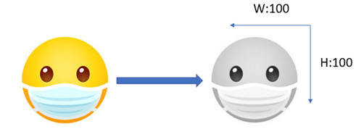

Figure 7.How the images will look like after resizing it to 100x100 dimensions and to gray-scale

Now, after the data is prepared in the two steps above we will detect the mask where each image will be passed through the classifier. Now as the image is converted to a 100x100 dimension, we will pass it to the trained module which will predict if the face is “mask” or “no-mask”. We then use OpenCv’s video capture function to load the system’s default webcam which will show us an output of “mask” and “no-mask” this step is called detecting the masks.

# **3.6.** **USER PREPARATION**

User preparation or audience building is determined of who you are attracting in your project and who can use it. Face mask detection application/software these days can be used on wide audience from companies to schools, shopping malls and also airports, kind of software can help us to control spreading the virus by warning us to put our mask on. However, this project is mostly targeting business that have workers returning to indoor facilities, as disobedience could lead to others in the workplace getting infected as it would be a great loss for a business if there was an outbreak because someone failed to wear a mask. So, existence of such software would be a great achievement in our society.

# 3.7. OBJECTIVE OF THE NEW DESIGN

The simplest the design can be the hardest as once said “make it simple but significant”, for this project design it was simple attractive user-friendly design with two steps for the face detection and for the mask detection, I’ll be using the face mask dataset, which consists of specific amount of images for example 100 images with 50 images containing people with face masks and 50 images containing people without face masks, for these images a model would be build using Tensor-flow lite object recognition to detect if you are wearing a face mask by using your phone’s and also by using the webcam of your PC.

The purpose of having simple design is to not make the user take much time to figure out how the software is used because normally if that is the case people tend to leave the software due how hard and time consuming it is to use the software, another reason for the simple design is the speed so we can let the application/software focus on the real data and processing instead of taking time in loading styles and scripts that will decrease the algorithm speed time and the application/software will take much time to load.

# 3.8. PROGRAM STRUCTURE

To understand the program structure of this project we have to present the java and Tensor-Flow Lite object recognition framework because they are structured in a way that won’t work if different structure was represented, we will represent the structure of these files later when we implement the codes.

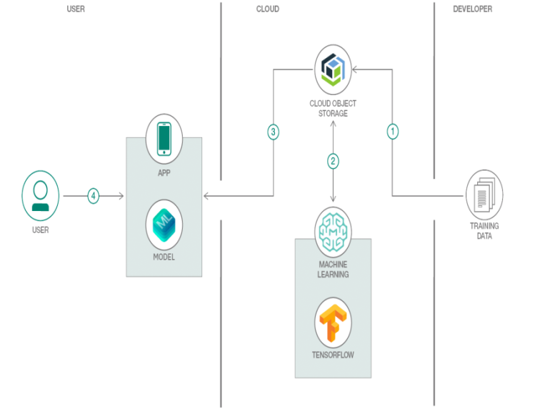As we can see from the figure below, in this project the trained data are uploaded to the IBM Cloud Object Storage, then the Google machine learning pulls (ML) the training data from IBM cloud object storage and trains a model with Tensor-Flow, the trained model is saved back to the IBM cloud object storage. After the pervious steps are done the trained modules are added to the app, the user then interacts with the app that can detect the faces in real time.

Figure 8.Tensor-Flow Lite object Detection module view template diagram.

# 3.9. FILE MAINTENANCE MODULE

For this web based project and because of the simple method in which this project was built on, this project can be easy for programmers to change or edit the image, the naming functions that are built will make it easier to figure out what each method does and how the data flow is.

# 3.10. MAIN MENU SPECIFICATION

This project (face mask detection) is designed as we know to detect individuals not wearing face masks in the frame. When a person is detected, the module will highlight them in the frame with a square in real time and send an alert to the system.

The module will be capable of detecting up to 5 people not wearing face masks in the frame at the same time, the module will not identify faces as it can’t tell one person from the other or compare a person’s face with the faces from a database, it’s job is only to find people with and without face masks in the frame.

When a “no mask” is detected, the module will highlight the person’s face with a red square in the client application and creates an event. The repeated detection of “no mask” by the same person may occur only after the disappearance of this person from the frame for a minimum of 3 seconds (example when a person leaves the frame or hides his face completely).

# 3.10.1. OUTPUT SPECIFICATIONS

In this project output’s specification I’ll talk about how the user can interact with such application and will explain the instructions in which the user can follow for him/her to interact good with this project application. The algorithm of the module will be based on the neural network detectors (CNN) model using TensorFlow and OpenCV which will be used for the face mask detection. There are instructions for the user to follow in order for him/her to interact with this application software. I will explain the instructions in the next part

# 3.10.2. INPUT SPECIFICATIONS

In this input specification project, I will discuss the instructions that will help the user to easily interact with this project application by showing some figures and explaining them. As we all know this kind of projects must be well explained for the users to easily interact with, so hopefully by putting some instructions and fully explaining them it will be easier for any user to get along with this application. Firstly, the video stream’s resolution for the user must be specific for example in this project the video resolution for the module’s operation is HD or FullHD, Secondly there must no mirrored surface as it will cause reflection in the frame which will lead to false output, Thirdly the faces in the frame must be uniform and constant, Fourthly, if the camera is installed opposite a bright source of light the user must adjust the brightness in a way that the face in the frame would be clear, Lastly**,** The camera must be placed above the face level, directly facing the people to be recognized

Here are some examples that any user may face and how to overcome them:

1. Overlapping

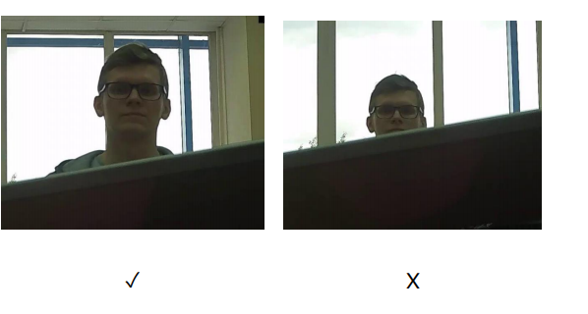

Figure 9.Show the video streaming problem and how the user can overcome this kind of situation by following the instructions above [[Ref].](https://eocortex.com/media/4846/download/eocortex-mask-detector-spec-en.pdf?v=1&inline=1)

1. Face illumination

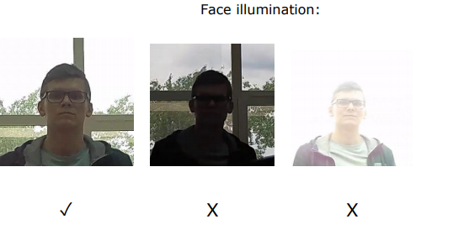

Figure 10.Show the face illumination problem and how the user can overcome this kind of situation by following the instructions above [[Ref]](https://eocortex.com/media/4846/download/eocortex-mask-detector-spec-en.pdf?v=1&inline=1)

1. Video stream quality

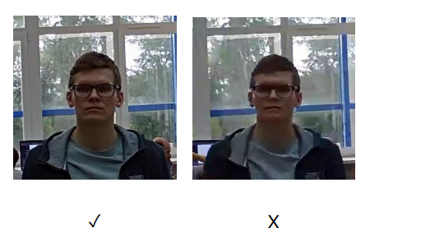

Figure 11.Show the video streaming problem and how the user can overcome this kind of situation by following the instructions above [[Ref]](https://eocortex.com/media/4846/download/eocortex-mask-detector-spec-en.pdf?v=1&inline=1)

1. Reflecting surfaces:

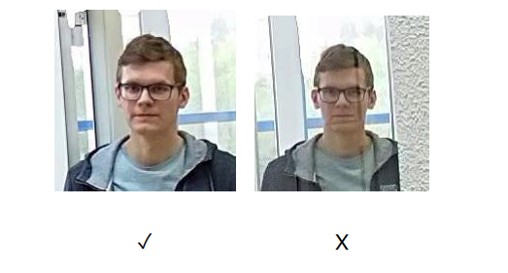

Figure 12.Shows the reflection surface and how the user can overcome this kind of situations by following the instructions above [[Ref]](https://eocortex.com/media/4846/download/eocortex-mask-detector-spec-en.pdf?v=1&inline=1).

Below are some examples of some supported face masks that will work for this project’s face detection webcam

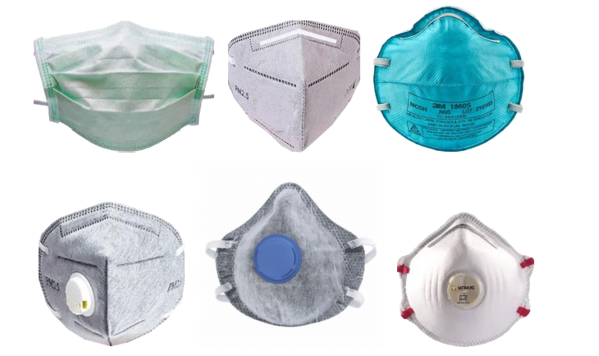

Figure 13.Shows the type of masks that are supported in this project’s application [Ref].

**Note:** If the face is covered by a hand or a scarf for example, this will result in triggering the detector, in case the nose is covered with a mask then the detector will not be triggered.

# 3.11. OVERVIEW OF THE PROPOSED SYSTEM DIAGRAM

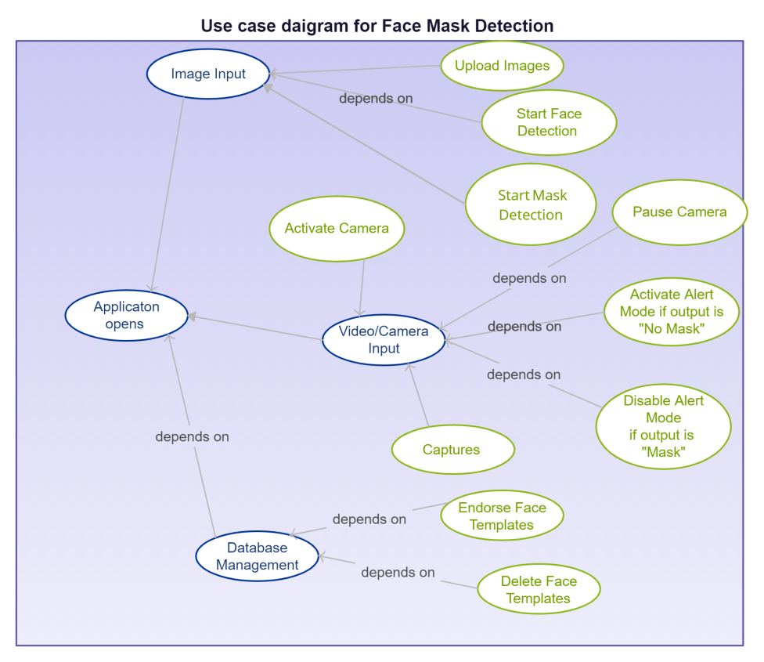

Figure 14.Shows the use case diagram for this project.

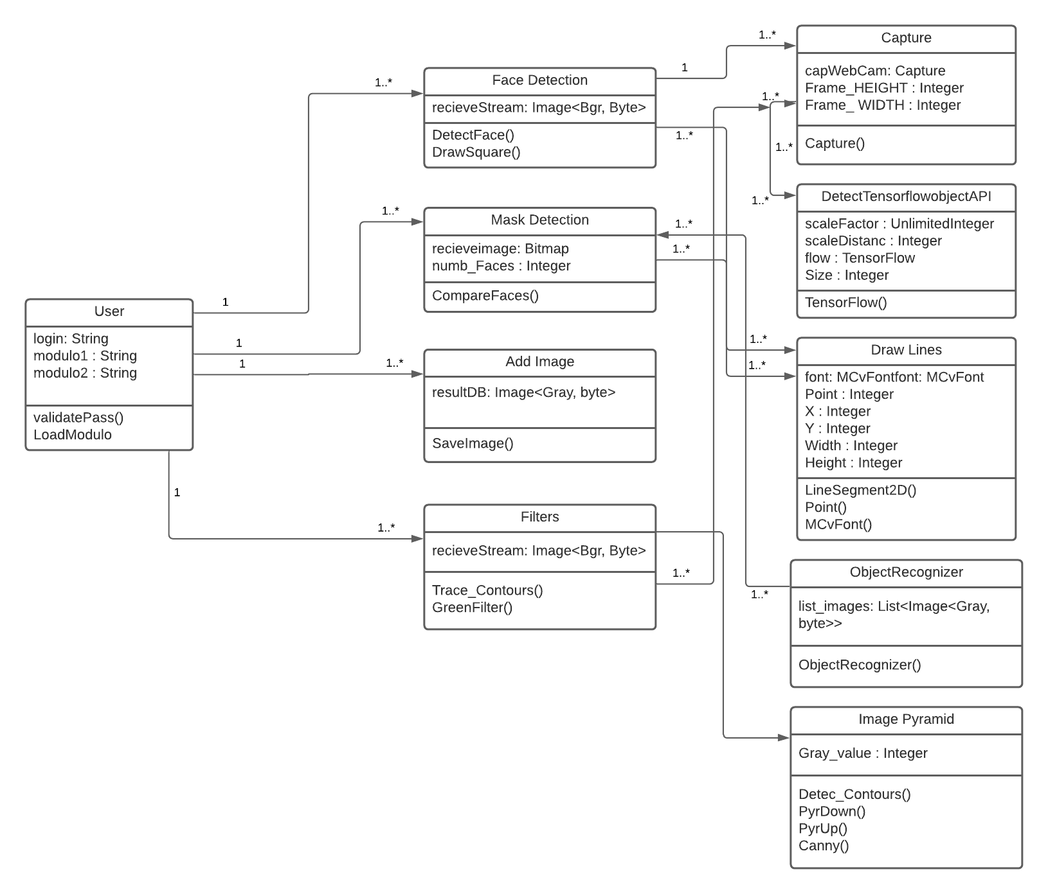

Figure 15.Shows a UML class diagram of face mask detection

Chapter Four

Summary, Recommendation & Conclusion

# CHAPTER Four – Summary, Recommendation & Conclusion

# SUMMARY

To sum up this project, a deep learning model was developed for face mask detection using Java as the programming code, Tensor flow and OpenCV. In this project the face mask detector was developed for detecting whether person is wearing a mask or not. Tensor-Flow model was trained using OpenCV libraries. Organizing the models and making them work together this was the first phase of the project. Testing the project using webcam with OpenCV is the second part.

# RECOMMENDATION

Face masks are the new weapon that people use to shield their selves from this pandemic, if companies had systems that detect whether a person is wearing a face mask or not it could have been a life saver, that’s why I recommend using Tensor-flow, OpenCV and Neural Network (CNN) stand by our side for better results and it also saves more time to save more lives. This face mask detector can be adopted in our daily routine places such as hospitals, work, universities, schools, airports, libraries, shopping malls and other heavy places to monitor the public and to avoid the disease from getting spread by checking who is following the safety rules which will help the world to be a better and safer place like it used to be.

# CONCLUSION

As a conclusion, we should understand and use the new technology for human safety and development which can make humans do less work and software do some of the hard work like monitoring the public for instance. These kind of software forces human to be more careful and to follow basic rules for our own safety, it also have it’s good side of creating more safe world to live in. That’s why I strongly stand with developing kind of software application which can be upgraded into a professional application as this will give an advantage for us humans to make us ready and also help us in crucial days like this.

# Presentation Link

**YouTube video:** <https://youtu.be/wn_c-IFZLP4>

# REFERENCES

[1] Sellden, Eva. 2010. “. [Is Routine Use of a Face Mask Necessary in the Operating Room? | Anesthesiology | American Society of Anesthesiologists (asahq.org)](https://pubs.asahq.org/anesthesiology/article/113/6/1447/9572/Is-Routine-Use-of-a-Face-Mask-Necessary-in-the) “

[2] HALLER, DAVID A., and RAYMOND C. COLWELL. 1918. “[THE PROTECTIVE QUALITIES OF THE GAUZE FACE MASK: EXPERIMENTAL STUDIES | JAMA | JAMA Network](https://jamanetwork.com/journals/jama/article-abstract/219245).” *Journal of the American Medical Association*. .

[3]

[Spooner, John L. 1967. “](Spooner, John L. 1967. \“History of Surgical Face Masks: The Myths, the Masks, and the Men and Women behind Them.\” AORN Journal. https://doi.org/10.1016/S0001-2092(08)71359-0.                                                                                                                         URL:  https://www.thelancet.com/journals/lancet/article/PIIS2213-2600(20)30352-0/fullte xt)[[History of Surgical Face Masks: T... preview & related info | Mendeley](Spooner, John L. 1967. \“History of Surgical Face Masks: The Myths, the Masks, and the Men and Women behind Them.\” AORN Journal. https://doi.org/10.1016/S0001-2092(08)71359-0.                                                                                                                         URL:  https://www.thelancet.com/journals/lancet/article/PIIS2213-2600(20)30352-0/fullte xt)](https://www.mendeley.com/catalogue/6e5bb4ee-abb3-3cd6-a0a0-67a5c55797a2/?utm_source=desktop&utm_medium=1.19.4&utm_campaign=open_catalog&userDocumentId=%7B143db496-1193-44ca-99e2-14761c1009cc%7D) [.”](Spooner, John L. 1967. \“History of Surgical Face Masks: The Myths, the Masks, and the Men and Women behind Them.\” AORN Journal. https://doi.org/10.1016/S0001-2092(08)71359-0.                                                                                                                         URL:  https://www.thelancet.com/journals/lancet/article/PIIS2213-2600(20)30352-0/fullte xt) *[AORN Journal](Spooner, John L. 1967. \“History of Surgical Face Masks: The Myths, the Masks, and the Men and Women behind Them.\” AORN Journal. https://doi.org/10.1016/S0001-2092(08)71359-0.                                                                                                                         URL:  https://www.thelancet.com/journals/lancet/article/PIIS2213-2600(20)30352-0/fullte xt)*[.](Spooner, John L. 1967. \“History of Surgical Face Masks: The Myths, the Masks, and the Men and Women behind Them.\” AORN Journal. https://doi.org/10.1016/S0001-2092(08)71359-0.                                                                                                                         URL:  https://www.thelancet.com/journals/lancet/article/PIIS2213-2600(20)30352-0/fullte xt)

[4] Adams, Lu Wang, Carol A. Aschenbrenner, Timothy T. Houle, and Raymond C. Roy. 2016. “[Uncovering the History of Operating Room Attire through Photographs | Anesthesiology | American Society of Anesthesiologists (asahq.org)](https://pubs.asahq.org/anesthesiology/article/124/1/19/14254/Uncovering-the-History-of-Operating-Room-Attire).” *Anesthesiology*.

[5] Kaplan D. [A TRANSPARENT MASK | JAMA | JAMA Network](https://jamanetwork.com/journals/jama/article-abstract/234818)

**[6]** Dhand, Rajiv, and Jie Li. 2020. “[Coughs and Sneezes: Their Role in Transmission of Respiratory Viral Infections, Including SARS-CoV-2 | American Journal of Respiratory and Critical Care Medicine (atsjournals.org)](https://www.atsjournals.org/doi/10.1164/rccm.202004-1263PP).” *American Journal of Respiratory and Critical Care Medicine*.

[7] Stadnytskyi, Valentyn, Christina E. Bax, Adriaan Bax, and Philip Anfinrud. 2020. “[The airborne lifetime of small speech droplets and their potential importance in SARS-CoV-2 transmission | PNAS](https://www.pnas.org/content/117/22/11875).” *Proceedings of the National Academy of Sciences of the United States of America*.

[8] Tunevall, Th Göran. 1991. “[Postoperative wound infections and surgical face masks: A controlled study | SpringerLink](https://link.springer.com/article/10.1007/BF01658736).” *World Journal of Surgery*.

[9] Schünemann, Holger J., Elie A. Akl, Roger Chou, Derek K. Chu, Mark Loeb, Tamara Lotfi, Reem A. Mustafa, et al. 2020. “[Use of facemasks during the COVID... preview & related info | Mendeley](https://www.mendeley.com/catalogue/2804c5fb-a337-3b17-b20b-f794d86b7db5/?utm_source=desktop&utm_medium=1.19.4&utm_campaign=open_catalog&userDocumentId=%7B51f792fe-d71a-4bc5-bb61-a9b4b509532f%7D).” *The Lancet Respiratory Medicine*.